FOUNDATION FOR VIRTUAL AND AUGMENTED REALITY SYSTEMS
Lecture15
Lec 15: AR Hardware
Hello and welcome to the NPTEL MOOC's course on Foundations for Virtual and Augmented Reality Systems. We are going to start our discussion on AR hardware. That is lecture number 8. As is customary, we will first quickly recap what we have learned previously. Previously, we focused on VR hardware.
So, there we saw VR. The overall idea of a VR system and different components of the hardware system that are part of the overall VR system, namely the input part, the processing part, and the output part. In a similar vein, we are going to learn about the different types of hardware that are generally used to provide AR experience. What we will do here is basically give an overview rather than going into the minute details of the hardware as we have done in the VR hardware discussion.
So, let us start our discussion on an overview of the AR hardware. This is a summary of different types of AR hardware. In subsequent parts of the lecture, we are going to talk in a little bit more detail about each of these categories of hardware. So, if we consider all augmented reality devices, then we can see that there can be different categories of such devices. For example, one category can be the headsets and glasses.
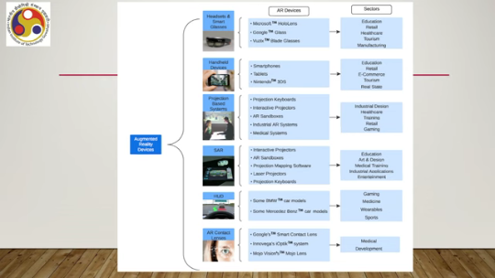
Then handheld devices, then projection-based systems, then spatial AR, head-up displays, and finally, AR contact lenses. Examples of each category are also shown here. So, for example, for headsets, we have AR HoloLens, Microsoft HoloLens. Then for smart glasses, we have Google Glass, Vuzix Blade Glasses, and so on.
Under the handheld device category, we have smartphones, tablets, and so on. Nintendo devices and so on. Under the projection-based system, we have projection keyboards, interactive projectors, AR sandboxes, industrial AR systems, and medical systems. Then under the spatial AR devices, we have interactive projectors, which were also part of the projection-based systems, but we will discuss them separately. Then AR sandboxes, projection mapping software, laser projectors, projection keyboards, and so on.
Note that here these interactive projectors and projection keyboards, these two categories are also mentioned here in this projection-based system: projection keyboards and interactive projectors. So, separately we will see in the later part of the lecture, we will discuss them separately. Then we have head-up displays, typically found in cars. Nowadays, almost all cars are
A few high-end cars are coming up with such head-up displays. And the latest technology that is being explored for AR systems is the contact lens. So, several research works are ongoing by Google, Innovega, Mojo Vision's Mojo Lens, and Innovega's iOptic system. These are some examples of such contact lens work going on. Also, in this summary, you can see the application side of these devices or categories of devices.
Say, for example, headsets and smart glasses can be used in education, retail, healthcare, tourism, and manufacturing. Handheld devices can be used in education, retail, e-commerce, tourism, and real estate. Projection-based systems and spatial AR systems can be used in industrial design, healthcare, training, retail, gaming, education, art and design, medical training, industrial applications, and entertainment. Head-up displays can be part of gaming experiences, medicine, wearables, and sports.
AR contact lenses can have applications in medical development. So, different application areas are there. Many categories are common to all the application areas. Some are uniquely placed. So, let us have a quick look at each of these technology categories.
So, let us start our discussion with the headsets. Earlier we talked about headsets for VR. Let us see In AR, what kind of headsets are we talking about? Generally, AR headsets are larger and more immersive in the sense that more content is there, a combination of both real-world content as well as augmented digital content.
So, generally they provide a wider field of view. and some advanced features which may not be there in VR headsets. In fact, those features may not be required in VR headsets at all because there it is not necessary to provide the real-world view. Now, the AR headsets typically include built-in sensors, often cameras and depth sensors. Some of these may or may not be there in VR headsets.
An example of an AR headset is Microsoft HoloLens shown here in this diagram. As you can see, it is packed with several components. So, we have depth cameras, two depth cameras marked here, then one microphone, noise-cancelling microphone, speaker here, port for attaching headphones, glasses, which are special types of glasses where real digital content can be projected on top of our regular real-world view.
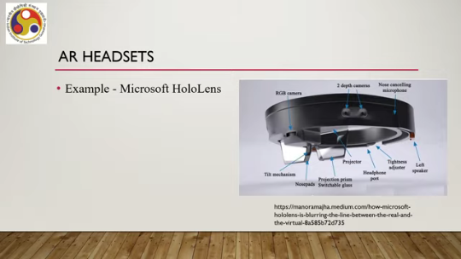
Then there are different mechanical arrangements like tilt mechanism and also some support stuff like nose pads. It also comes with one camera here and one projector located here. This device, Microsoft HoloLens, comes with a lot of sensors, cameras, depth cameras, and so on. Many of these are not relevant for VR. So, typically, VR headsets do not have so many components.
So, in this particular device, what happens is that high-definition holograms or the digital content are integrated with the real-world view. which is obtained through the glasses. As we have seen, it contains sensors, high-resolution 3D optical HMD, and spatial audio capabilities. As we have seen before, AR must be interactive, and the interaction in the case of HoloLens takes place through eye movements, voice commands, and hand motions.
So, the device comes equipped with detection of eye movements, voice commands, and hand gestures. So, this is about the headsets. HoloLens is only one example; there are other such headsets available. Let us talk a little bit about the other category of device, that is, smart glasses. Now, unlike these HMDs, AR HMDs, or headsets, smart glasses that are also used for AR application deployment are typically lighter.
They are just like our glasses, less immersive, and resemble a pair of standard eyeglasses. They tend to often have a smaller field of view as compared to AR headsets. But because they are lighter and a more familiar kind of device, they are usually more comfortable to wear for extended periods as compared to headsets. The glasses provide simpler heads-up display type AR digital content overlays rather than full 3D holograms of AR headsets. So that is quite natural because headsets come packed with various components, sensors, and projectors, whereas glasses do not have so many components.
An earlier example of such AR glasses is the Google Glass. It presents data in a format similar to a smartphone but operates hands-free. And here interaction can take place through voice commands in natural language. So, it comes equipped with detection of such commands. So, the glasses are shown here in this accompanying figure.
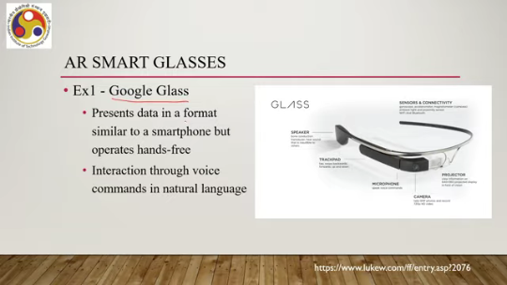
So, you can see there are lots of sensors present here like gyroscope, accelerometer, magnetometer. Ambient light and proximity sensors, Wi-Fi and Bluetooth, all these things are there. Also, it comes with a speaker, trackpad, microphone, camera, projector, but the power of these devices is less as compared to similar components like projector or camera in a headset. Another example is Vuzix's Blade shown here. This also comes with lots of sensors for tracking as well as actuators for output.
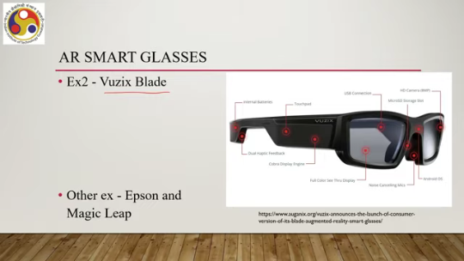
Say for example, it has dual haptic feedback components, display engine, see-through display, that is the glass part. Noise-cancelling microphones, Android OS, memory storage, camera, USB connectivity, touchpad and so on, even a place to store or keep batteries. So, there are other such glasses. Nowadays, in fact, this trend of providing AR experience through smart glasses is catching up compared to 10 years ago. Now, this field is quite active.
So, there are other examples like Epson glasses and Magic Leap glasses. So, those are about headsets and wearables. So, we have under headset powerful wearables. Sensors, glasses are less powerful, wearable, but more compatible to use for longer duration. Then let us shift our focus to the next category that is handheld devices.
These are typically the familiar devices like smartphones or tablets. They are the most common and also accessible devices that are used in AR. So, as we all know, these devices come with their own camera. So, that device camera can be used to capture real world images, which are displayed on the screen of the device. And then on top of the screen, digital content is augmented.
So, overlaying of virtual information happens onto the live streaming of real world environment. So, we have already seen these handheld devices typically rely on two main technologies: marker-based and markerless. We have talked about it earlier. Just to recap, in the case of marker-based AR, there are some markers placed in the real world. The system recognizes through image recognition those markers and then
augments specific visual, augments specific content where the markers are recognized. Examples of such markers are QR codes or other fiducial markers. We also can have markerless AR. Again, just to recap, this uses different sensors such as GPS or computer vision techniques to detect objects in the real world and then augment content in the real world view digitally.
The third category of AR devices are the spatial augmented reality devices. So, what are these devices? Let us have a brief understanding. So, these are also known as room-scale AR or tabletop AR. These devices typically use projectors to display graphical information on physical objects.
So, unlike the previous categories where we discussed headsets or glasses or even handheld devices. In such cases, the digital content is overlaid on our view of the real world, whereas in the spatial AR devices, the digital content is overlaid on some physical objects, not on our view of the real world. Now, those physical objects are present in the real world. And we get to see something digitally projected on those physical objects to give us an AR experience.
So, the defining features of spatial AR devices are that the display element is not tied to the users. So, in other cases like the headsets or glasses or handheld devices, the display element is always tied to the user. The user is holding that, but here the display element can be independent of the users. It can provide more natural and intuitive interfaces as compared to the previous ones.
Such devices allow multiple users to interact with the content simultaneously. Unlike the previous cases where each user can interact with the digital content on his or her own, there is no possibility of others being able to interact with the digital content viewed on the user's device. In the case of spatial AR, that is not the limiting factor. Multiple users can interact simultaneously with the augmentation of the digital content on the physical object.
There can be several applications of such devices related to education, art and design, medical training, industrial applications, museums and exhibits, entertainment. These are major application areas where spatial AR devices and systems can be used. So, the fundamental principle of any spatial AR system is that it augments the physical environment by adding virtual objects that seem to coexist within the same space as the real objects.
So, the way things are implemented in case of spatial AR indicates that whatever is augmented with the digital content seems to coexist with the physical space surrounding the user. Now, the implementation of this idea requires an understanding of the physical environment's geometry and the lighting conditions. Otherwise, seamless mixing may not be possible. Now, that can be achieved using advanced depth sensors or computer vision techniques. So, typically those are part of
any spatial AR system. Now, earlier we talked about different projection-based and spatial AR systems, but in our example discussions we will merge these two categories and talk of all of these as spatial AR systems. So, that the confusion related to which device belongs to which category, projection-based or spatial AR-based, is no longer there. Both generally refer to similar ideas. So, let us begin with our examples of spatial layer systems.
One example is interactive projectors. So, they can project images onto any surface, turning the surface into an interactive display. An example is shown here. You see the projector. This is a tabletop.
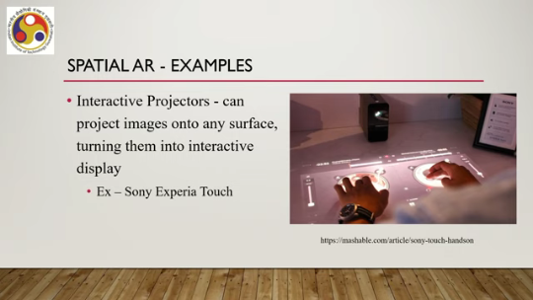
and the projector projects this interface on the tabletop which can be interacted with as shown here and accordingly the tabletop converts to an interactive display and at the same time there is interaction, there is augmentation of digital content on the physical space that is the tabletop. So, it is an AR experience. An example is Sony Xperia Touch. Another interesting example is the air sandboxes.
What happens here is that these devices project a topographic map onto a sandbox, a box full of sand. As users move the sand around, changing the landscape, a sensor detects changes and the projector adjusts the map in real time. So this is the idea illustrated here in this accompanying figure. So we can see a physical box full of sand. So sand is kept inside this box part.
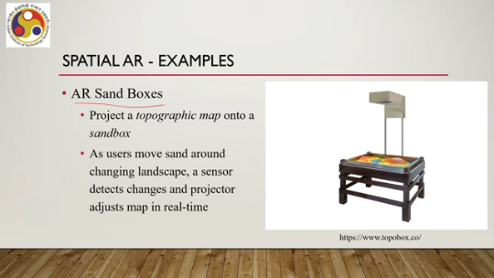
Then there is a projector. It also has a sensor to detect hand movement or the change in the sand's landscape. As you can see, on top of the sand, some digital projection is made. Now, this projection changes based on the movement of sand or the way the user's hands move. So, earlier we talked about one defining characteristic of such spatial layer systems is that multiple users can work together on the
augmented digital content. A prime example is this type of sandbox where 2-3 users can play around with the sand and accordingly the topographical map will change. So, this is the idea of a sandbox which is a prime example of spatial AR as well as a prime example of multi-user engagement with AR systems. One way to implement such a sandbox is to use a 3D camera to detect the gestures and accordingly change the topographical map; such a camera can be integrated into the system such as Microsoft Kinect and of course we require a projector and a physical sandbox.
Another example is a projection keyboard. Now, these are probably quite familiar to many of you. Like projection surfaces earlier, here also a projector is used which projects a keyboard on any surface, converting that surface into an interactive keyboard. So, it projects a virtual keyboard onto a flat surface allowing users
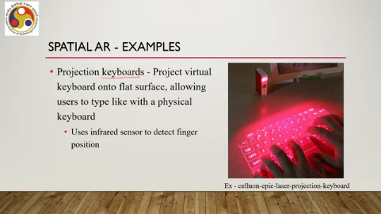
to type like with a physical keyboard. And in order to detect the key press activities, it may use infrared sensors to detect finger positions. That is the more common way to deal with interaction. Another interesting application is the projection mapping technology. done through software means.
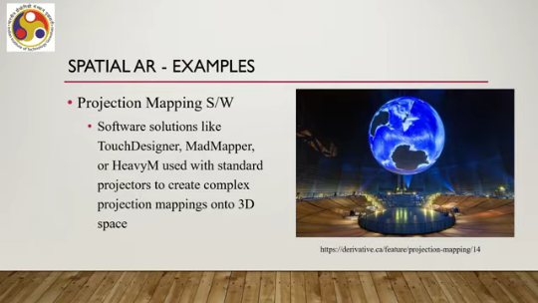
So, here in 3D we can project any object like shown here: a map of the or a model of the earth shown in air without any surface. Now, this can be done using software solutions such as TouchDesigner, MadMapper, or HeavyM which are used with standard projectors to create complex projection mapping onto 3D space without any surface. And those can also be interacted with, say for example, rotated or pinched and so on, zoom in, zoom out type of things and so on. Typically, those are quite common nowadays in entertainment,
and gaming industries. So, these are major categories. There are a few more categories of AR displays available. Let us have a quick look. Head-up display or HUD can be one such category.
These are nowadays quite commonly seen in cars. What happens in these displays is that they project images onto a transparent surface, usually a screen or a visor. So, ideally the surface appears to not be there and only the content is there because the surface is transparent. However, it may not be as transparent as an ideal transparent surface.
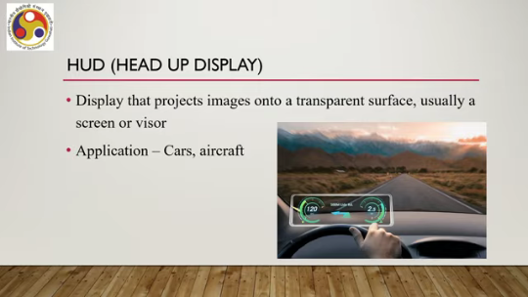
So, some borders or shades may be visible. They are quite commonly used nowadays in cars and aircraft. The final category that we can talk about, which is still emerging and evolving, is the AR contact lenses. So, note that whatever we have discussed so far required elaborate setups. HMDs are quite bulky, glasses also,
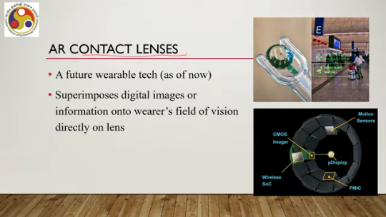
Bulky, but not so much as HMDs, but still they take up some space. Handheld devices are quite bulky. Even smartphones and tablets can be very difficult to hold in hand for a long time. Spatial AR systems require you to carry a projector or a full setup. HUDs are quite limited in application, so we are not considering them.
The latest trend is contact lenses, which are very small and can be placed directly on the eye like any regular contact lens. They will not even be visible to outsiders, and on top of it, they can be used for AR applications. So, it is a kind of future wearable technology. As of now, it is still in the realm of the future. It superimposes digital images or information onto the wearer's field of vision directly on the lens.
And these lenses from the outside may appear simple, but inside there are a lot of things in the lenses. There can be imagers made on CMOS technology, display, other components, even wireless components, motion sensors, sophisticated components miniaturized and placed on the contact lens, the wearable device. Use case can be like this: suppose if you are wearing such a contact lens, you may be able to see it, see this type of information in front of you and there may be ways to interact or change this information.
Say for example, you can get to see information related to flights, seats while seeing the real world in front of you as shown in this accompanying figure. So, this idea may be quite appealing and a lot of work is going on with this idea. Hopefully soon we may get to see such devices in the market. However, it is still not very clear what the effect on the user will be.
So if we get to see a lot of information directly in front of our eyes, whether that will affect our normal behavior or or may lead to some sort of sickness, because the information may keep on changing. So, whether that is going to have any effect or not, these things are still not well known, still not researched, and may or may not be an issue. However, the idea is quite appealing. Some example systems are Google's smart contact lens project under which this type of lens is being developed.
Then InnoVega's eye optic system, Mojo Vision's Mojo Lens. So, these are some of the activities that are carried out nowadays to develop such technology. So, with that, we have come to the end of this lecture on AR hardware. So let us quickly summarize what we have learned.
We talked about different categories of AR hardware systems, broadly five categories: headsets and glasses, that is wearable, the wearable category, then the handheld category of devices, then spatial AR devices, head-up displays, and contact lenses. Under wearable, we have seen two types of wearables. Headsets, which are quite old by now, old technology, old concept, whereas glasses are state-of-the-art, coming up very fast. Handheld devices are more commonly used, more affordable, more ubiquitous devices used for AR applications.
Then we have Spatial AR systems, spatial type of AR experience with distinct features, distinct functionalities. We talked about projection keyboards or other projection systems, then sandbox, AR sandbox and projection mapping, and so on. HUDs are nowadays commonly seen in cars. They are quite commonly used in aircraft nowadays.
And finally, the upcoming contact lens, AR contact lenses, that is the state of the art that is going to be a good technology if implemented and probably going to be quite popular depending on the affordability. With that, we have covered our discussion. We have covered both AR hardware and VR hardware. Another hardware part that we are yet to discuss is the hardware used for tracking.
So, bits and pieces of tracking technology and tracking hardware we have already discussed. In the next lecture, we are going to have a comprehensive discussion on the tracking hardware that is used in both AR and VR. So, that is all for this lecture. I hope you enjoyed and understood the concepts. This is the reference from where I have used most of the material covered in this lecture.

If you get time, you may go through it to know in more detail all the topics that I have discussed. So, it is quite recent, from 2023. So, I suggest you go through this reference or any relevant reference related to AR hardware. Thank you and happy learning. See you in the next lecture.

